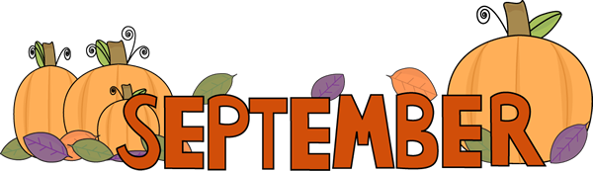
Page County Senior Center Activities Calendar
Activities Are Subject to Change Without Notice

MONDAY | TUESDAY | WEDNESDAY | THURSDAY | FRIDAY
 | 1.  9:30 Coffee & Group Social  10:00 Congregate Choice  11:00 Old Maids Game  12:00 Lunch | 2.  9:30 Coffee & Group Social  10:30 Rileyville Joy Club  Wear Blue Shirts | 3.  9:30 Coffee & Group Social  10:00 Blood Pressure Checks  11:00 Chair Exercise  12:00 Lunch | 4.  CLOSED
7.  CLOSED  In Observance of Labor Day | 8.  9:30 Coffee & Group Social  10:00 JMU Nursing Students  11:00 JMU Nursing Students Cont.  Tech Savy Tuesday  12:00 Lunch | 9.  9:30 Coffee & Group Social  10:00 Music Therapy  11:00 Diamond Art Cont.  12:00 Lunch | 10.  9:30 Coffee & Group Social  10:00 Blood Pressure Checks  11:00 Congregate Choice  12:00 Lunch | 11.  CLOSED
14.  9:30 Coffee & Group Social\  10:00 Congregate Choice  11:00 Golden Memories Game  12:00 Lunch | 15.  WARREN COUNTY  TRIAD  FRONT ROYAL MOOSE  Please Wear Blue Shirts  Leaving At 9:15 | 16.  9:30 Coffee & Group Social  10:00 Fun Word Sheets  11:00 Pokeno Game  12:00 Lunch | 17.  9:30 Coffee & Group Social  10:00 Blood Pressure Checks  11:00 Chair Exercises  12:00 Lunch | 18.  CLOSED
21.  9:30 Coffee & Group Social  10:00 Music Therapy  11:00 Bingo  12:00 Lunch | 22.  9:30 Coffee & Group Social  10:00 Congregate Choice  11:00 Fall/ Halloween Decorating  12:00 Lunch  First Day of Fall  National Ice-cream Cone Day | 23.  9:30 Coffee & Group Social  10:00 Blood Pressure Checks  11:00 Fall Fun Sheets  12:00 Lunch | 24.  9:30 Coffee & Group Social  10:00 Shopping Trip Around Luray  Must Be Signed Up & On Time  12:00 Lunch | 25.  CLOSED
28.  9:30 Coffee & Group Social  10:00 JMU Nursing Students  11:00 JMU Students Cont.  12:00 Lunch | 29.  CLOSED  Staff Training | 30.  9:30 Coffee & Group Social  10:00 Music Therapy  11:00  12:00 Lunch | 

